**CS 3354: Software Engineering**

**Final Project Deliverable I**

**Movie Theater Ticketing System**

Jessica Allen

Gladys Adjei

Aishwarya Tirumani

Rebecca LaDeau

**Final Project Draft Description**

Our group chose to create a Theater Ticketing System that allows users to book seats online. We chose this project because we thought it would be sufficiently complex and comprehensive enough to challenge us, but still feasible to design. We also thought the many facets of a theater ticketing system would stimulate our creativity, as there are a lot of options that we can choose to implement if we want. We have all visited movie theaters and reserved tickets and seats online; websites and apps like Fandango.com are very popular for searching and purchasing movie tickets. This type of third party purchasing system is familiar to us, it seemed a good choice for this project.

Obviously, we would expect our design to be used as a mobile app where users can reserve seats for a particular movie time online. In its implementation, there will be multiple theater rooms playing different movies at different times and each room will have a specified number of seats available. The user will be able to select the specific seat(s) they want to book and then they will be able to pay for their seats through the app. These reservations could be saved and retrieved by a central database.

This type of system could be used in the real world by theaters like Cinemark, LOOK Cinemas, AMC, Studio Movie Grill and others. Many of these businesses implement similar systems already of varying complexity. These systems are always being improved to accommodate a growing customer base.

**1. Delegation of Tasks**

|  |  |
| --- | --- |
| **Tasks** | **Assigned to:** |
| Edited final project draft description (proofread based on professor feedback) | Jessica Allen,  Gladys Adjei,  Aishwarya Tirumani,  Rebecca LaDeau |
| What software process was used and why? | Jessica Allen |
| **Effort, Timeline, and Cost Estimation** | |
| Details of duration and cost estimations for project | Rebecca LaDeau,  Aishwarya Tirumani |
| What effort estimation method was adopted? Why? | Rebecca LaDeau |
| Estimated cost of hardware products | Aishwarya Tirumani |
| Estimated cost of software products | Aishwarya Tirumani |
| Estimated cost of personnel | Aishwarya Tirumani |
| Timeline plot for project including individual tasks and duration | Rebecca Ladeau |
| **Software Requirements Specification** | |
| Functional and Nonfunctional Requirements | Jessica Allen,  Gladys Adjei,  Aishwarya Tirumani,  Rebecca LaDeau |
| Requirement Allocation | Gladys Adjei |
| Architectural design - Block diagram | Jessica Allen |
| Architectural style - N-tier | Gladys Adjei |

**2. Software Process and Why**

Constraints of our Project

* 4 total software engineers
* approximate 3 month timeline
* small, relatively simple project

Our project will necessarily be completed in a short timeframe by a small number of people. Based on our initial descriptions, our project will be relatively straightforward. Because we will need to concentrate our efforts on tackling multiple features of the project at a time, we chose to follow an agile process model. With only four team members present, it is necessary to follow a model that emphasizes teamwork and consistent communication and testing. To complete the project by the required date, we will need to work together closely. The agile process model accommodates that objective the most easily.

**3. Effort and Cost Estimation**

**3.1 Estimated Effort**

Method: Function Point

Reasoning:

We chose to use the Function Point effort estimation method for our project. Although it is sometimes seen as "subjective," David Kung in "Object Oriented Software Engineering: An Agile Unified Methodology" states that it can be used by people with fairly low-level technical skills. Everyone in our group is studying Computer Science, however we do not necessarily have the expertise or experience to understand all technical areas of our project. The concepts related to a ticketing system are familiar to us, but an application domain with servers and databases reaches beyond our current studies. We also chose this method because another one of its advantages is it can be used early in the project's lifecycle, and does not favor any one programming language. Since Effort Estimation is required for our First Deliverable, this seemed to be the right choice. We also are not required to write a program for this project, so leaving the implementation language open to future choice is advantageous, if we ever choose to fully employ this project.

Gross Function Point:

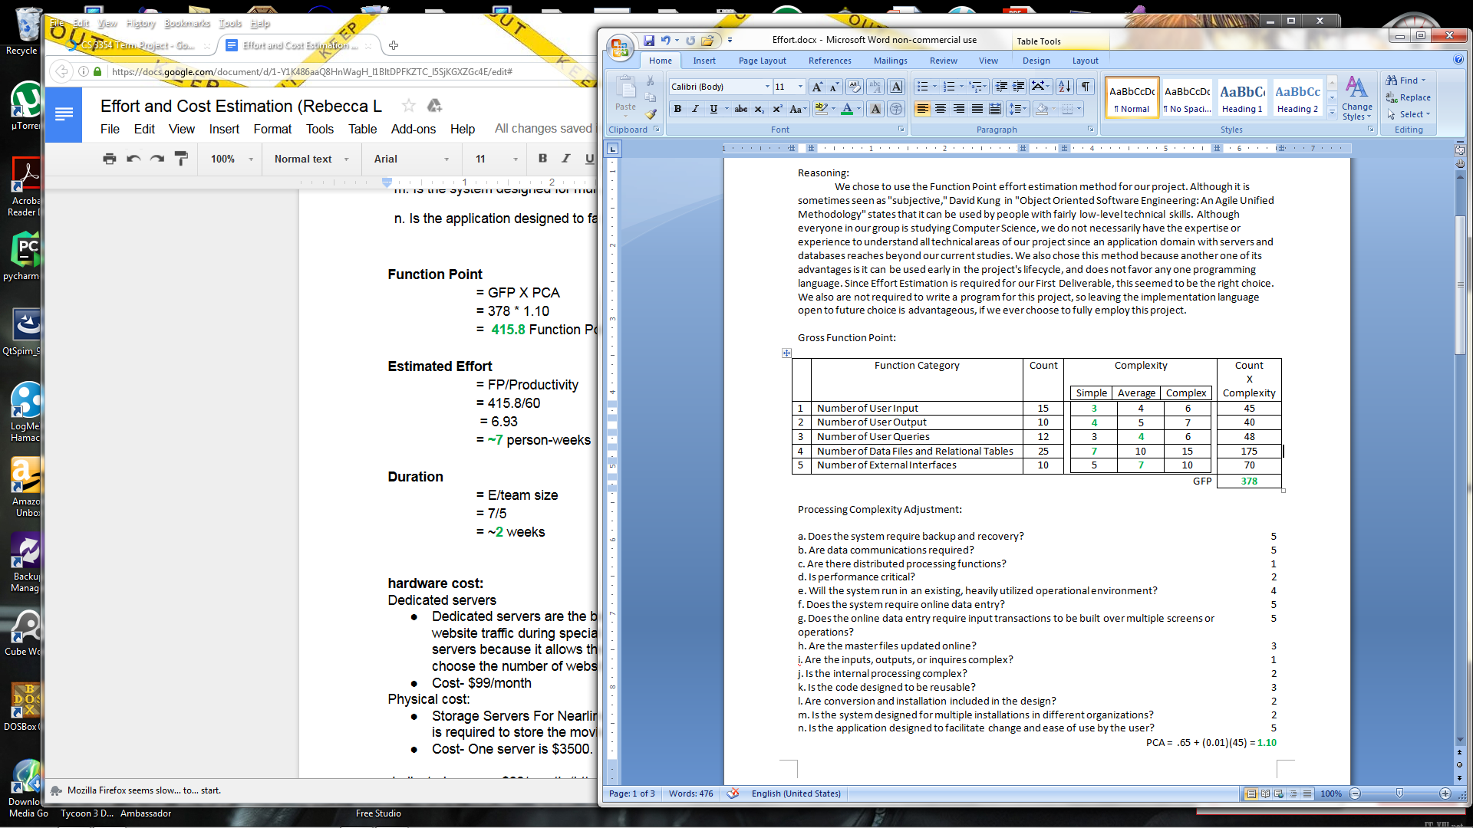

Processing Complexity Adjustment:

|  |  |
| --- | --- |
| a. Does the system require backup and recovery? | 5 |
| b. Are data communications required? | 5 |
| c. Are there distributed processing functions? | 1 |
| d. Is performance critical? | 2 |
| e. Will the system run in an existing, heavily utilized operational environment? | 4 |
| f. Does the system require online data entry? | 5 |
| g. Does the online data entry require input transactions to be built over multiple screens or operations? | 5 |
| h. Are the master files updated online? | 3 |
| i. Are the inputs, outputs, or inquires complex? | 1 |
| j. Is the internal processing complex? | 2 |
| k. Is the code designed to be reusable? | 3 |
| l. Are conversion and installation included in the design? | 2 |
| m. Is the system designed for multiple installations in different organizations? | 2 |
| n. Is the application designed to facilitate change and ease of use by the user? | 5 |

PCA = .65 + (0.01)(43) = **1.10**

**Function Point**

= GFP X PCA

= 378 * 1.10

= **415.8** Function Points

**Estimated Effort**

= FP/Productivity

= 415.8/60

= 6.93

= **~7** person-weeks

**Duration**

= E/team size

= 7/5

= ~**2** weeks

**3.2. Estimated cost of hardware products:**

Dedicated servers:

* Dedicated servers are the best for the ticketing system because there will be high website traffic during special screenings and weekends. It is safer to purchase dedicated servers because it allows the developers to control the system. Allows the developer to choose the number of websites and gives more flexibility.
* Cost- $99/month [6]

Physical cost:

# Storage Servers For Nearline is the best server for high performance and storage which is required to store the movies and bookings.

* Cost- One server is $3500. [7]

Total Hardware Cost:

Cost of dedicated servers + physical cost = approximate cost of hardware products

$99(5) + $3,500(5) = $17,995

**3.3. Estimated cost of software products:**

Visual Studio Professional with MSDN 2015: $1,199/license [8]

* Suitable for small groups, stable and run longer.
* It is flexible to create a app from Windows, Android or iOS.
* It is easier to implement the project into code if desired because all the changes made by the team members are notified to reduce less confusion.

Domain Name:

* $10-$15/ year. [6] New domain names are cheaper and cost less.

Adobe Suite: $70/month [9]

* Provides powerful tools for creating images suitable for a professional user interface
* Offers a subscription for “use-as-you-go” that can work for short or long projects

Total Software Cost:

Cost of visual studio professional + cost of Domain Name + cost of Adobe suite = approximate cost of software products

$1,199 + $15 + $70 = $1,284

**3.4. Estimated cost of personnel:**

Application Developer(1)

$70,000/year [1]

For 2 weeks = $2,916.67

Software Developer(2)

$85,000/year [2]

For two weeks = $3541.667 + $3541.667 = $7,083.33

Graphics Designer(1)

$50,000/year [3]

For two weeks = $2,083.33

Software Engineer, Project Manager(1)

$120,000/year [4]

For two weeks = $5,000

Launch Training

About $1,500/per employee [5]

For possibly 10 employees = $1,500(10) = $15,000

Total Personnel Cost

One Application Developers + two Software Developers + one Graphic Designer + one Project Manager + ten training per employee = approximate cost of personnel

$2,916.67 + $7,083.33 + $2,083.33 + $5,000 + $15,000 = $32,083.33

**3.5 Total Project Cost**

Hardware Cost + Software Cost + Personnel Cost = approximate total cost

$17,995 + $1,284 + $32,083.33 = **$51,382.33**

**3.6 Timeline Plot**

The timeline for our project follows an agile unified methodology. The duration calculated in our effort estimation is about two weeks for a team of five people, which we have broken down into a Software Engineer Project Engineer, an App Developer, a Graphics Designer, and two Software Engineers. The first part of the timeline covers the "Planning" phase. Note that this phase is short, as agile processes prefer actual programming to extensive diagrams. The second part contains the "Iterative" phase, with two iterations. The first iteration allows more time for modeling activities, as the second iteration only considers these activities briefly. In both iterations, the focus is on code implementation and testing. We also include a final "Deployment" stage where the Ticketing System will be integrated into the target environment. This goes beyond the scope of two weeks, but we feel this stage is needed.

(Note: A larger image has been included in the zip file)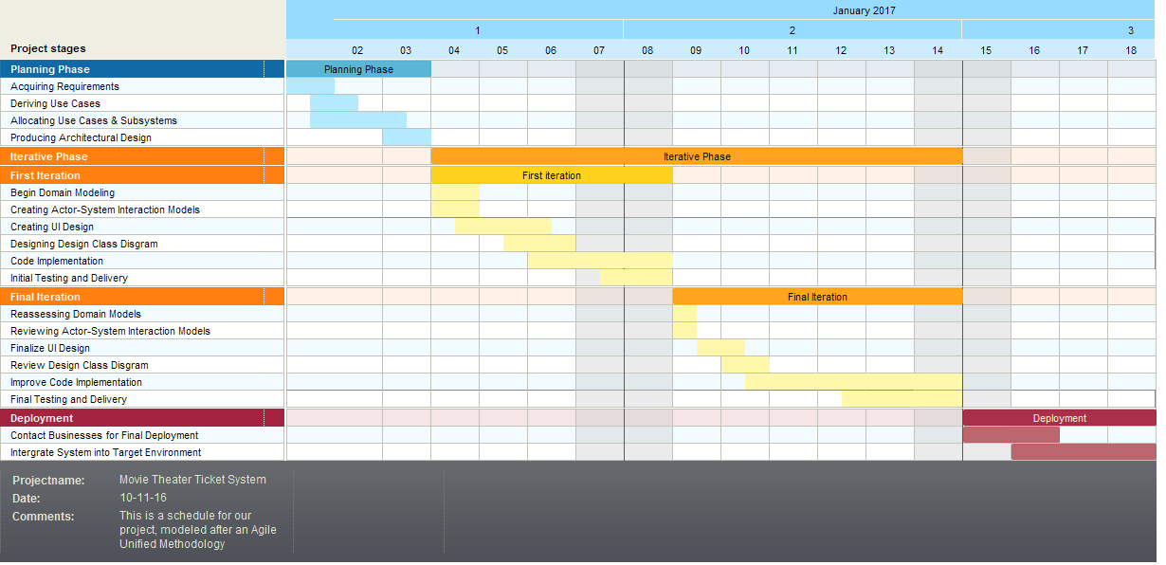

**4. Software Requirements Specification (SRS)**

**4.1. Functional Requirements**

*Theater and Account Information:*

**R1.** TTS must effectively stream the necessary data from the theatres’ databases

**R2.** TTS must store information regarding past, current, and future showings: dates, times, movie titles, movie summaries, rating, and number of tickets remaining.

**R3.** TTS must store all account information in a secure database.

*User Accounts:*

**R4.** TTS must allow account holder to sign into account before beginning any transaction activity

**R5**. The ticketing system must allow potential user to create an account at the time of purchase.

**R5.1.** TTS must request user’s information such as name, address, phone number, email, preferred theatre, and payment information in order to set up account.

**R5.2.** TTS must allow user to create a password while setting up an account.

**R5.3.** TTS must send user email notification of account creation.

**R6.** TTS must allow user to view account and update information.

**R6.1.** TTS must allow user to change password.

**R6.2.** TTS must request user’s email when user wants to change password

**R6.3.** TTS must email user link to create new password

*Search Process:*

**R7.** TTS must allow user to query for nearby theatre.

**R7.1.** TTS must request for user to select user’s state and city.

**R7.2.** TTS must provide listings of theater based on several user’s geographic selection.

**R7.3.** TTS must provide user the option of selecting preferred theater from the list or selecting to view showings in all theaters on the list.

*View Showings:*

**R8.** TTS must allow potential customers to view available showings for current and future dates up to two weeks in advance, at select movie theaters.

**R9.** TTS must allow user to be able to select specific days to view movie lists for the respective day.

**R10.**TTS must allow user to be able to view showings from previous days, however, it will not allow transactions for expired showings.

**R11.** TTS must display showing information including showing time, rating (G, PG, PG-13, R, MA, NR), duration of movie, movie genre, theatre and room(s) at which the particular movie is being shown

**R12.** TTS must not allow user to be able select showing time that is before the time at which user is attempting to purchase ticket.

**R13.** TTS must automatically update the list of current showings as they become available and remove expired showings.

**R14.** TTS must display the number of tickets remaining for each showing.

*Reservations:*

**R15.** TTS must allow user to reserve tickets for available showings

**R15.1.** TTS must allow user to choose from three ticket types: adult, senior, and child.

**R15.2.** TTS must not allow user to reserve more tickets than are available.

*Seating:*

**R16.** TTS must allow user to select preferred seats in the theatre room

**R17.** TTS must display a simple bird view of the available seats in the room.

**R17.1.** TTS must be able to accurately display the available seats in respect to the selected showing

**R17.2.** TTS must only display disabled seating options for showings with available disabled seating remaining.

**R18.** TTS must not allow user to reserve more or less seats than tickets selected

**R18.1.** TTS must allow user to select exact number of seats as tickets selected

**R18.1.2.** TTS must not allow user to proceed until seats are selected

*Payments:*

**R19.** TTS must allow for user to decide whether to proceed to payment or continue shopping for more tickets.

**R20.** TTS must deny invalid forms of payments and alert user of error

**R21.** TTS must deny purchases for unavailable showtimes and seats.

**R22.** TTS must verify and validate payment information.

**R23.** TTS must only accept as payment visa, MasterCard, American Express, Discover, or gift card that is of the selected theatre.

**R24.** TTS must provide user a 4-minute window after selection to pay, after which, seats will be forfeited and user must reselect tickets.

**R25.** TTS must keep card information secure.

**R26.** TTS must be able to process unlimited transactions daily.

**R27.** TTS must request for user’s email or phone number if user is not signed into an account or opts out of creating an account.

**R28.** TTS must display a purchase summary and confirmation number to the interface after customer purchases ticket(s).

**R29.** TTS must automatically send a ticket confirmation email to customer’s email address after purchase.

**R30.** TTS must be able to display tickets in printable format.

**R31.** TTS must allow account holder to access/view purchased tickets.

*Admin Abilities:*

**R32.** TTS must allow system administrator to add, update or edit showtimes.

**R33.** TTS must allow system administrator to delete showtimes.

**R34.** TTS must allow system administrator change time and duration of existing showtimes.

**R35.** TTS must allow system administrator to add searchable theater listings.

**R36.** TTS must allow system administrator to view account details.

**4.2. Non-functional Requirements**

*Performance:*

**R37.** TTS must be able to process a typical workload of at least 500 inquiries at a time without adverse effects.

**R38.** TTS must have a response time of less than three seconds.

*Quality:*

**R39.** TTS must perform updates and maintenance during low traffic times.

**R40.** TTS must be available 99% of the time.

**R41.** TTS must update available information within 3 seconds of event (customer purchase, showing expiration, showing sold-out).

*Safety:*

**R42.** TTS must save and protect customer’s transaction histories and information.

*Security:*

**R43.** TTS must encrypt all data transferred via the internet, including customer transaction information.

**R44.** TTS must protect the website from malicious attacks and protect the information and privacy of its customers.

**R45.** TTS must require customers to re-enter their passwords before purchases.

Interface:

**R46.** TTS must be completely compatible and runnable on Windows 2000 or later, UNIX, LINUX, Mac operating systems, and any other standard OS.

**R47.** TTS must be compatible with any standard browser.

**R48.** TTS interface must be desktop and mobile responsive.

**R49.** TTS must update interface for the user upon manual refresh of the webpage.

**R50.** TTS must present an interface that is functional, easy to navigate, and user-friendly.

**5. Requirements Allocation**

|  |  |  |  |
| --- | --- | --- | --- |
| Functional Cluster | Functional Description | System Requirements | Functional Subsystem Identified |
| Account control | This functional cluster is responsible for managing account activity | R3, R4, R5, R5.1, R5.2, R5.3, R6, R6.1, R6.2, R6.3, R31, R36 | Account Management Subsystem |
| Theatre settings | This functional cluster is responsible for providing the accessible theaters | R1, R7, R7.1, R7.2, R7.3, R35 | Theater Selection Subsystem |
| Showings | This functional cluster is responsible for maintaining showings information | R2, R8, R9, R10, R11, R12, R13, R14, R32, R33, R34 | Movie Selection Subsystem |
| Ticket purchase | This functional cluster is responsible for regulating reservation transactions | R15, R15.1, R15.2, R16, R17, R17.1, R17.2, R18, R18.1, R18.1.1 | Ticket Subsystem |
| Payment | This functional cluster is responsible for processing purchasing transactions | R19, R20, R21, R22, R23, R24, R25, R26, R27, R28, R29, R30 | Payment Subsystem |
| Software Control | This functional cluster is responsible for coordinating activities of and between the subsystems as well as ensuring a high quality and performance of the system. | R37, R38, R39, R40, R41, R42, R43, R44, R45, R46, R47, R48, R49, R50 | Software Control Subsystem |

|  |  |  |  |  |  |  |
| --- | --- | --- | --- | --- | --- | --- |
|  | Account Management Subsystem | Theater Selection Subsystem | Movie Selection Subsystem | Ticket Subsystem | Payment Subsystem | Software Control Subsystem |
| R1 |  | X |  |  |  |  |
| R2 |  |  | X |  |  |  |
| R3 | X |  |  |  |  |  |
| R4 | X |  |  |  |  |  |
| R5 | X |  |  |  |  |  |
| R5.1 | X |  |  |  |  |  |
| R5.2 | X |  |  |  |  |  |
| R5.3 | X |  |  |  |  |  |
| R6 | X |  |  |  |  |  |
| R6.1 | X |  |  |  |  |  |
| R6.2 | X |  |  |  |  |  |
| R6.3 | X |  |  |  |  |  |
| R7 |  | X |  |  |  |  |
| R7.1 |  | X |  |  |  |  |
| R7.2 |  | X |  |  |  |  |
| R7.3 |  | X |  |  |  |  |
| R8 |  |  | X |  |  |  |
| R9 |  |  | X |  |  |  |
| R10 |  |  | X |  |  |  |
| R11 |  |  | X |  |  |  |
| R12 |  |  | X |  |  |  |
| R13 |  |  | X |  |  |  |
| R14 |  |  | X |  |  |  |
| R15 |  |  |  | X |  |  |
| R15.1 |  |  |  | X |  |  |
| R12.2 |  |  |  | X |  |  |
| R16 |  |  |  | X |  |  |
| R17 |  |  |  | X |  |  |
| R17.1 |  |  |  | X |  |  |
| R17.2 |  |  |  | X |  |  |
| R18 |  |  |  | X |  |  |
| R18.1 |  |  |  | X |  |  |
| R18.1.1 |  |  |  | X |  |  |
| R19 |  |  |  |  | X |  |
| R20 |  |  |  |  | X |  |
| R21 |  |  |  |  | X |  |
| R22 |  |  |  |  | X |  |
| R23 |  |  |  |  | X |  |
| R24 |  |  |  |  | X |  |
| R25 |  |  |  |  | X |  |
| R26 |  |  |  |  | X |  |
| R27 |  |  |  |  | X |  |
| R28 |  |  |  |  | X |  |
| R29 |  |  |  |  | X |  |
| R30 |  |  |  |  | X |  |
| R31 | X |  |  |  |  |  |
| R32 |  |  | X |  |  |  |
| R33 |  |  | X |  |  |  |
| R34 |  |  | X |  |  |  |
| R35 |  | X |  |  |  |  |
| R36 | X |  |  |  |  |  |
| R37 |  |  |  |  |  | X |
| R38 |  |  |  |  |  | X |
| R39 |  |  |  |  |  | X |
| R40 |  |  |  |  |  | X |
| R41 |  |  |  |  |  | X |
| R42 |  |  |  |  |  | X |
| R43 |  |  |  |  |  | X |
| R44 |  |  |  |  |  | X |
| R45 |  |  |  |  |  | X |
| R46 |  |  |  |  |  | X |
| R47 |  |  |  |  |  | X |
| R48 |  |  |  |  |  | X |
| R49 |  |  |  |  |  | X |
| R50 |  |  |  |  |  | X |

**6. Block Diagram**

Block Diagram.png

(Note: A larger image has been included in the zip file)

**7. Architectural Design:** 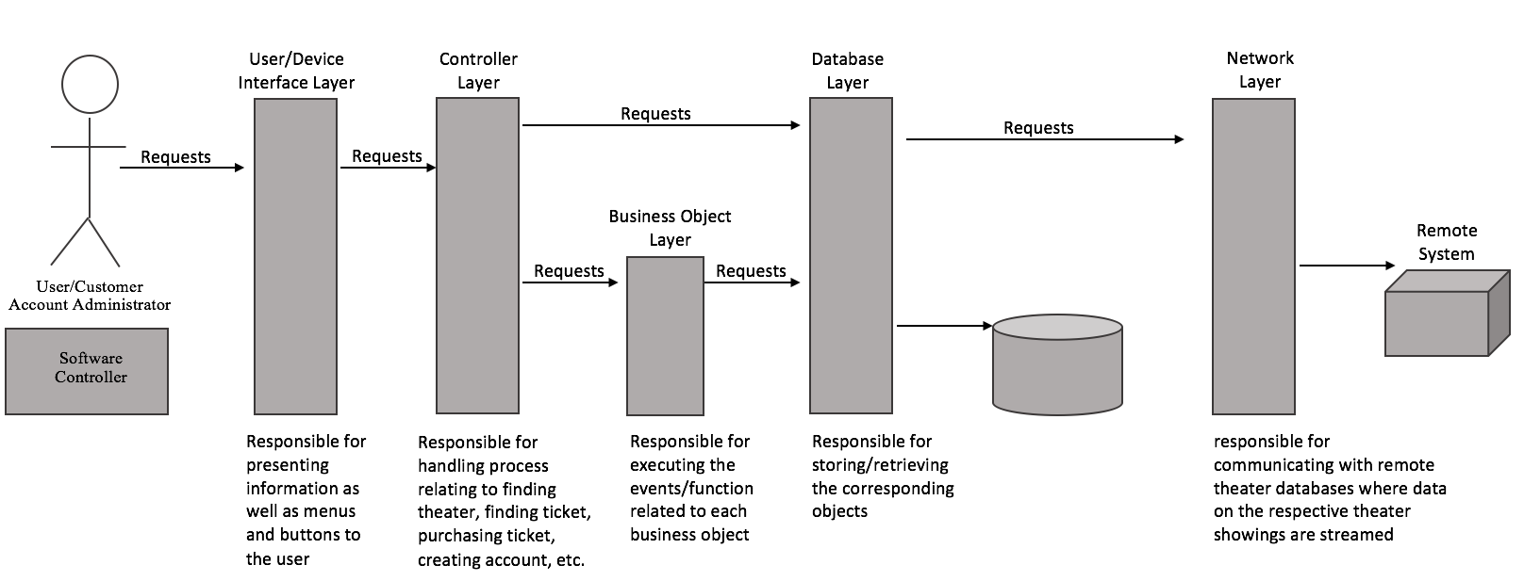

(Note: A larger image has been included in the zip file)

The Movie Ticketing System is a primarily interactive system, with users interacting with a website to order their tickets and the website responding to these requests. Therefore, due to the interactive nature of our project, the N-tier was selected as our architectural style.

**Works Cited**

[1] "Application Developer Salaries," in *Glassdoor*, 2016. [Online]. Available:

https://www.glassdoor.com/Salaries/application-developer-salary-SRCH_KO0,21.htm.

Accessed: Oct. 11, 2016.

[2] "Software Developer Salaries," in *Glassdoor*, 2016. [Online]. Available:

https://www.glassdoor.com/Salaries/software-developer-salary-SRCH_KO0,18.htm.

Accessed: Oct. 11, 2016.

[3] "Graphic Designer Salaries," in *Glassdoor*, 2016. [Online]. Available:

https://www.glassdoor.com/Salaries/graphic-designer-salary-SRCH_KO0,16.htm. Accessed: Oct. 11, 2016.

[4] "Software Engineer, Project Manager Salaries," in *Glassdoor*, 2016. [Online]. Available:

<https://www.glassdoor.com/Salaries/software-engineer-project-manager-salary-SRCH_K>

O0,33.htm. Accessed: Oct. 11, 2016.

[5] S. Linn, "The True Cost of Employee Training Programs," in *Group Management*

*Services*, 2015. [Online]. Available:

[http://www.groupmgmt.com/blog/post/2015/06/02/The-True-Cost-of-Employee-Training](http://www.groupmgmt.com/blog/post/2015/06/02/The-True-Cost-of-Employee-Training-)

[-](http://www.groupmgmt.com/blog/post/2015/06/02/The-True-Cost-of-Employee-Training-)

Programs.aspx. Accessed: Oct. 11, 2016.

[6] K. Engel, "How Much Does a Website Really Cost?," in *Who is Hosting This?*, 2014.

[Online]. Available: http://www.whoishostingthis.com/blog/2014/07/29/website-cost/.

Accessed: Oct. 11, 2016.

[7] "Thinkmate," in *Storage Servers For Nearline*, 2016. [Online].

Available:http://www.thinkmate.com/systems/storage/stx-nl. Accessed: Oct. 11, 2016.

[8] "Microsoft," in *Visual Studio Professional with MSDN*, 2016. [Online]. Available:

<https://www.microsoftstore.com/store/msusa/en_US/pdp/Visual-Studio-Professional-with>

-MSDN/productID.323825100. Accessed: Oct. 11, 2016.

[9] "Plans: Discover the Creative Cloud experience," in *Adobe*, 2016. [Online]. Available:

https://creative.adobe.com/plans. Accessed: Oct. 11, 2016.